Order Entry Database

John Wensink

MIS417 Database Concepts

Colorado State University – Global Campus

Professor Nathan Braun

August 18, 2018

Order Entry Database

Here are the deliverables for the Order Entry Database for Module 5, Option 1.

**Create New Database**

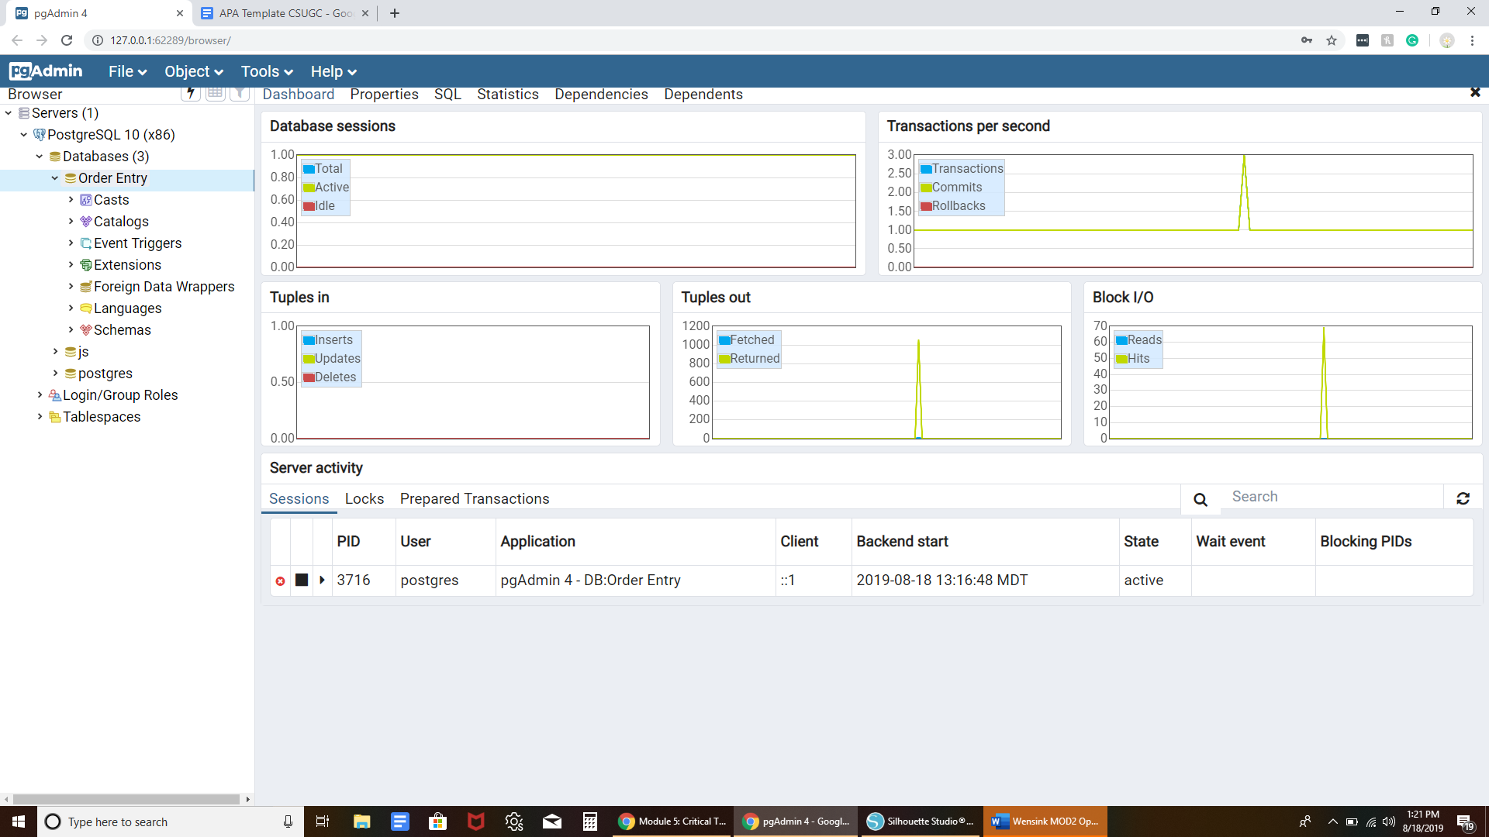

**Create Tables**

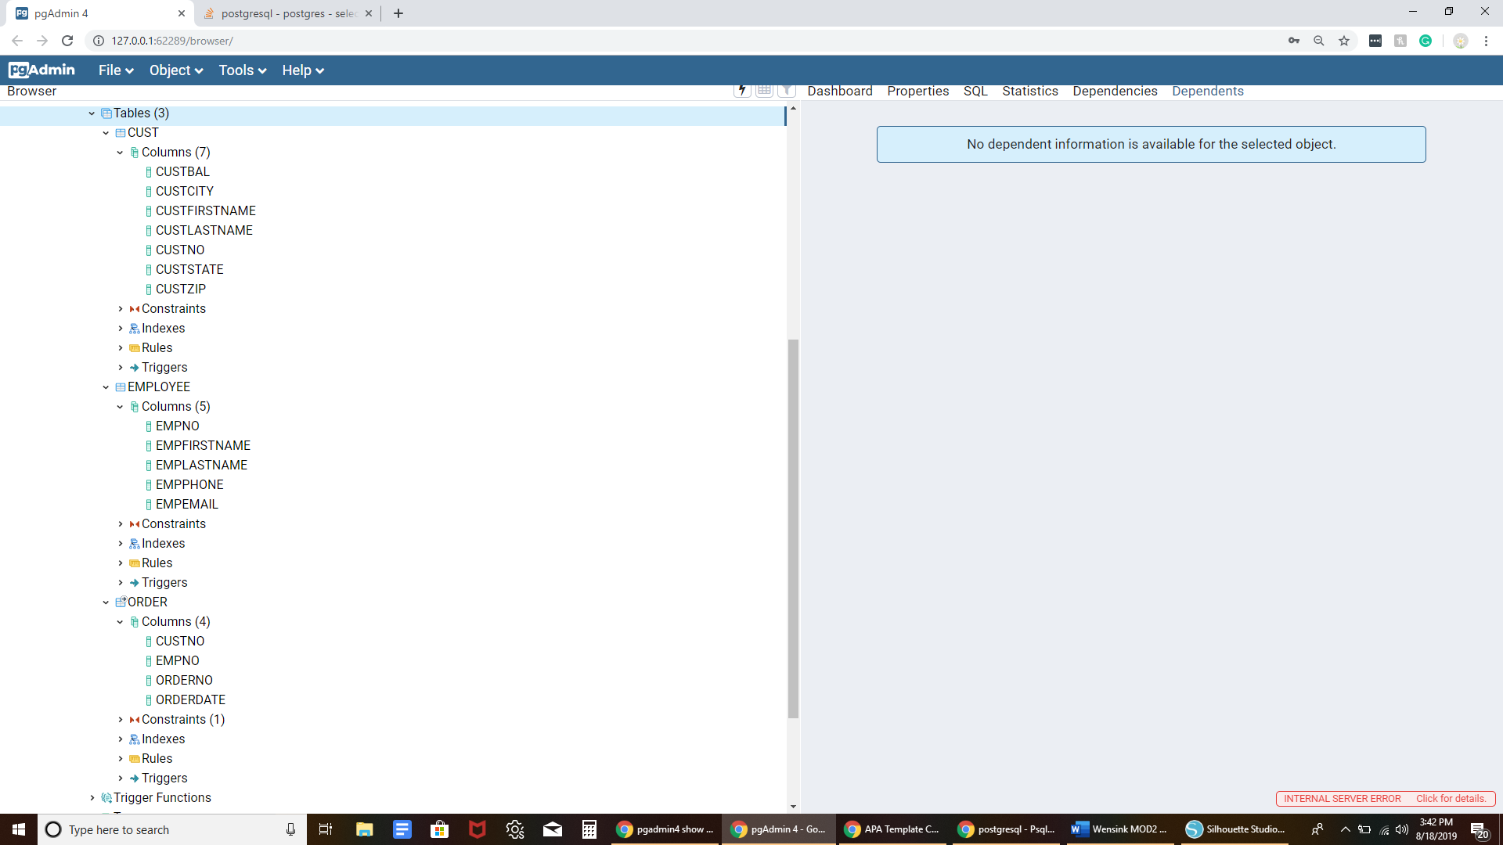

**Populated Tables**

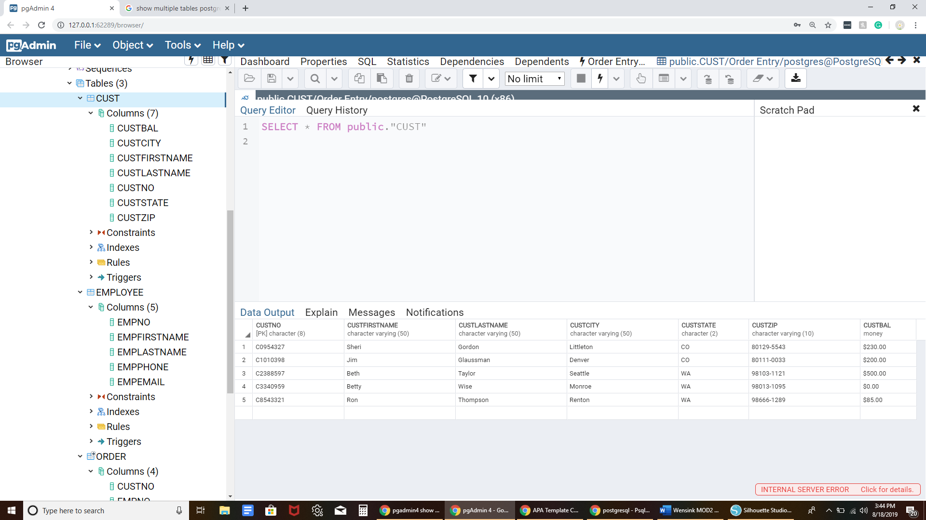

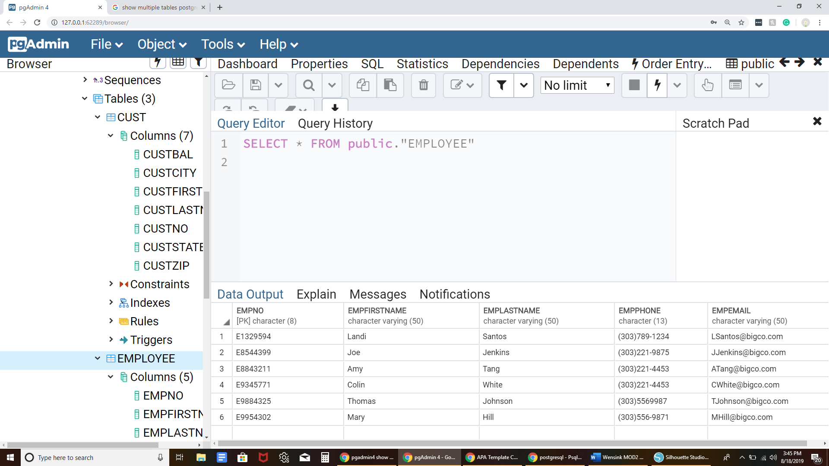

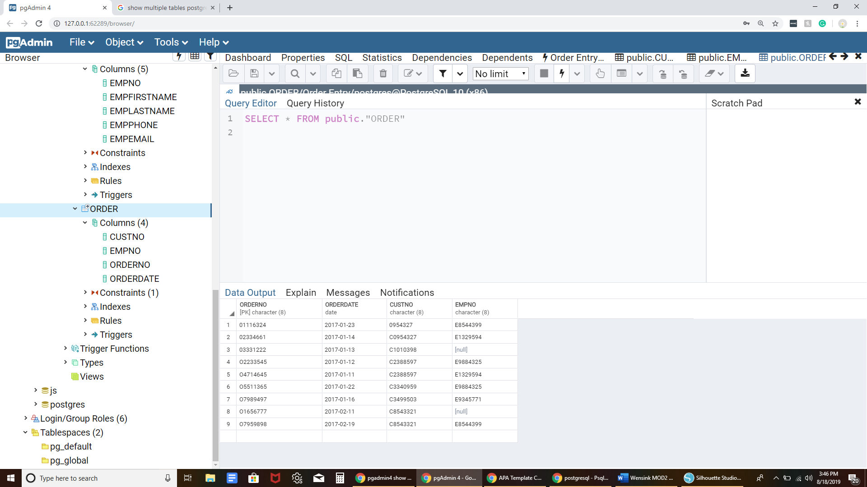

**Learnings**

This week’s CT homework was a challenge for me. This was a week where I think a physical classroom setting might have saved me hours of frustration. I’m sure with more practice my competency will grow, but for now it seems like I’m having to teach myself this difficult material without any real help. A quiet place to study would also have been helpful but despite multiple requests, my wife just would not keep the noise down. Last week when we shifted focus to physical database design, the textbooks started to lose meaning to me and most of what I read remains over my head. I read the words but I don’t understand what they’re trying to teach me. I feel like in this class the focus is on understanding that these database concepts exist, rather than gaining mastery of every detail. Maybe I’m being too hard on myself but I had a frustrating time trying to implement foreign keys into my tables, executing even a single SQL statement without cheating using the GUI. Even when I copy/pasted the scripts directly from the GUI I would still get syntax errors for which I have no idea how to resolve. Ultimately, I failed at implementing foreign keys, displaying all three tables at the same time, and making meaningful relations. I will probably watch some youtube videos after I finish this week’s discussion and mastery exercise. I’m sure I’m not the only one in class that felt that this was a hard week.